**Designing And Developing of an Online Computer Mart (CMart)**

**“Design Document”**

**Version 1.0**



**Group ID: F200216FF3 (MC190407078)**

**Supervisor Name: Muhammad Qamar Usman**

**Revision History**

|  |  |  |  |
| --- | --- | --- | --- |
| **Date (dd/mm/yyyy)** | **Version** | **Description** | **Author** |
| 18/1/2021 | 1.0 | The purpose of this document is to describe the implementation of “**Designing and Development of an Online Computer Mart (CMart)”** website.  Design documentation is a collection of documents and resources that covers all aspects of your product design. Documentation should include information about users, product features, and project deadlines; all essential implementation details ERD, Test Case, Database diagram, Sequence diagram, user interface | MC190407078 |
|  |  |  |  |
|  |  |  |  |
|  |  |  |  |

**Table of Contents**

1. Introduction of Design Document
2. Entity Relationship Diagram (ERD)
3. Sequence Diagrams
4. Architecture Design Diagram
5. Class Diagram
6. Database Design
7. Interface Design
8. Test Cases

**“Introduction of Design Document”**

The project is to develop an Online Computer Mart (CMart) site; it provides great flexibility to buy easily computer accessories by online.

**Design documentation** is a collection of **documents** and resources that covers all aspects of your software **design.** The document gives a brief account of different operations that are performed by system describe the relationship between these operations within as well as outside the system. This phase represents the “How” phase. Details on computer programming languages and environments, machines, packages, application architecture, distributed architecture layering, memory size, platform, algorithms, data structures, global type definitions, interfaces and many other engineering details are the deliverables of design phase. This document presents the designs used or intended to be used in implementing the project.

**Purpose of design document:**

The purpose of the Software Design Document is to provide a description of the design of a system fully enough to allow for software development to proceed with an understanding to be built and how it is expected to built. Design documents are also referred to as functional specifications or functional specifications documents, or functional requirements specifications

**Benefits of design document:**

1. This makes help in keep an eye on project during its development.
2. It important for marketing and investors information materials.
3. It very simple and an effective way for communication with others whose are interested in product investment.
4. It helps to keep an eye on all aspects of application and it improvements regarding software product quality.
5. Focuses on maintenance of product, development of product &about transferring of knowledge to other developers & designers.
6. It is the critical component which brings the innovation in engineering life.

**The design document of an Online Computer Mart (CMart) includes:**

* **Entity Relationship Diagram (ERD)**
* **Sequence Diagram**
* **Architecture Design Diagram**
* **Class Diagram**
* **Database Design**
* **Interface Design**
* **Test Cases**

**“Entity Relationship Diagram (ERD)”**

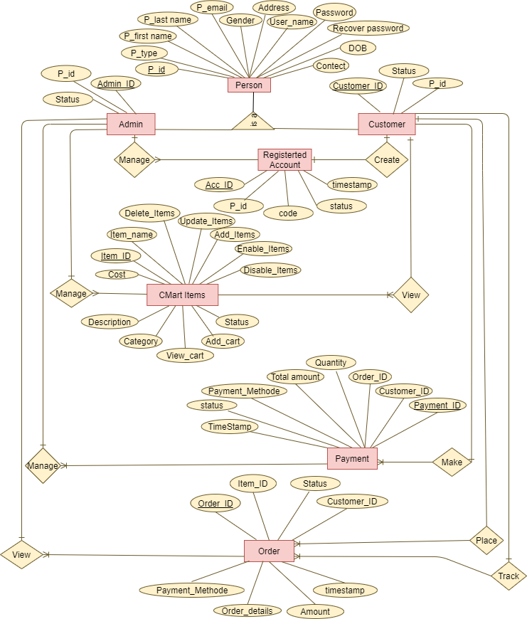

**“Sequence Diagrams”**

























**“Architecture Design Diagram”**

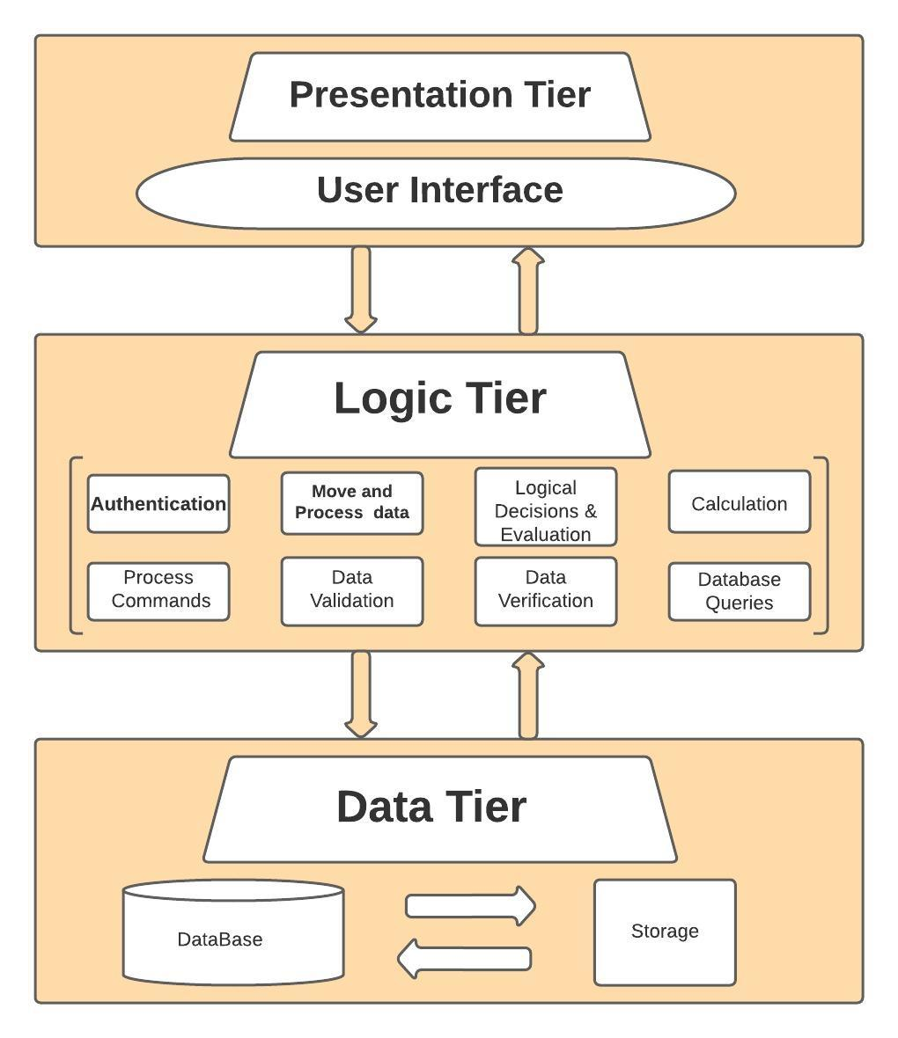

**“Class Diagram”**

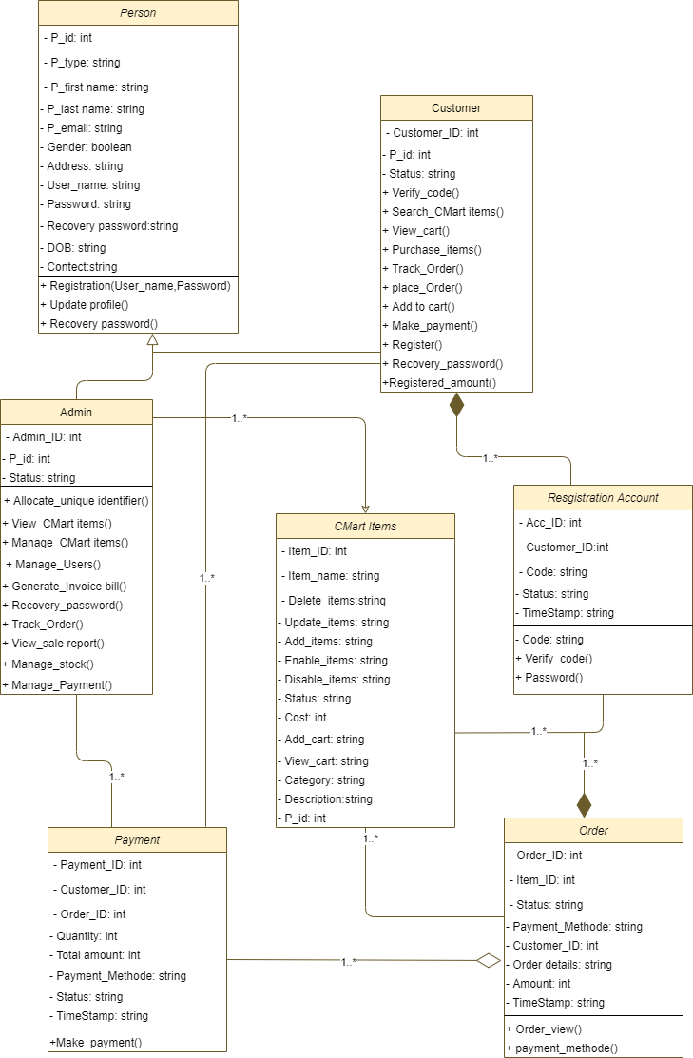

**“Database Design”**

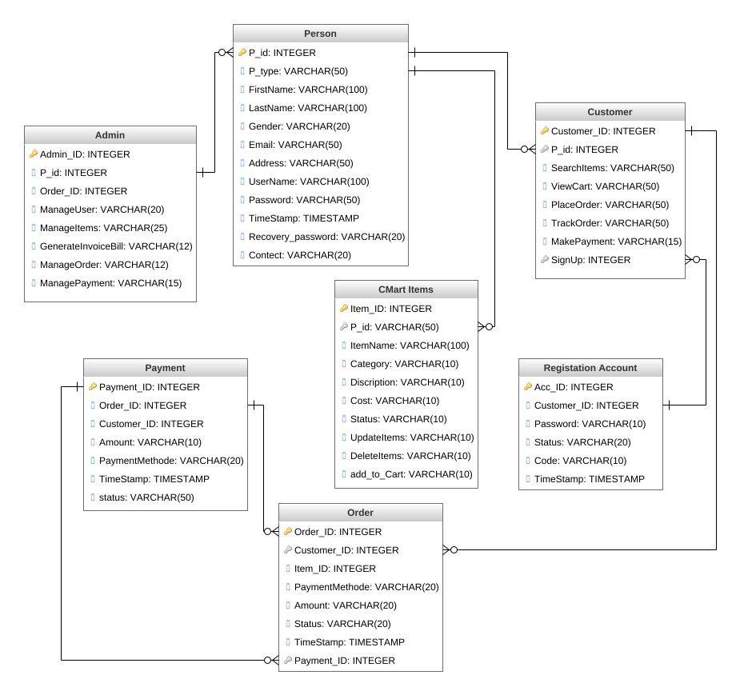

**“Interface Design”**

1. **Login Page:**

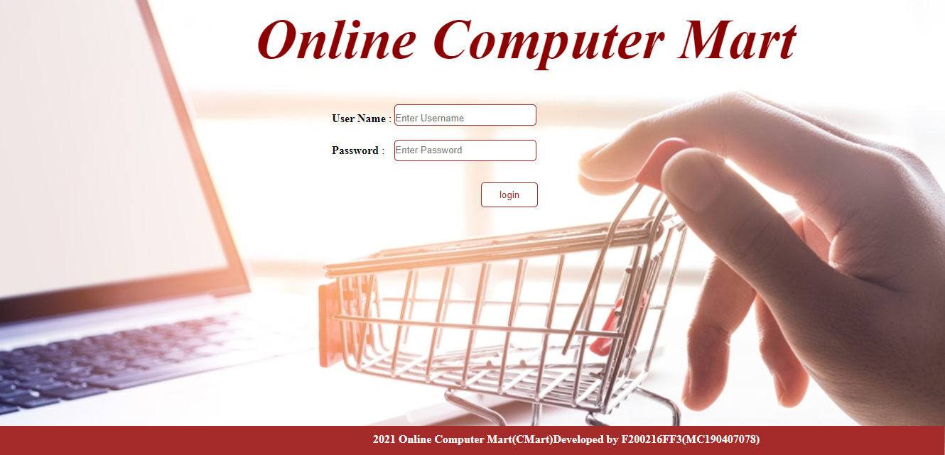

1. **Registration Page:**

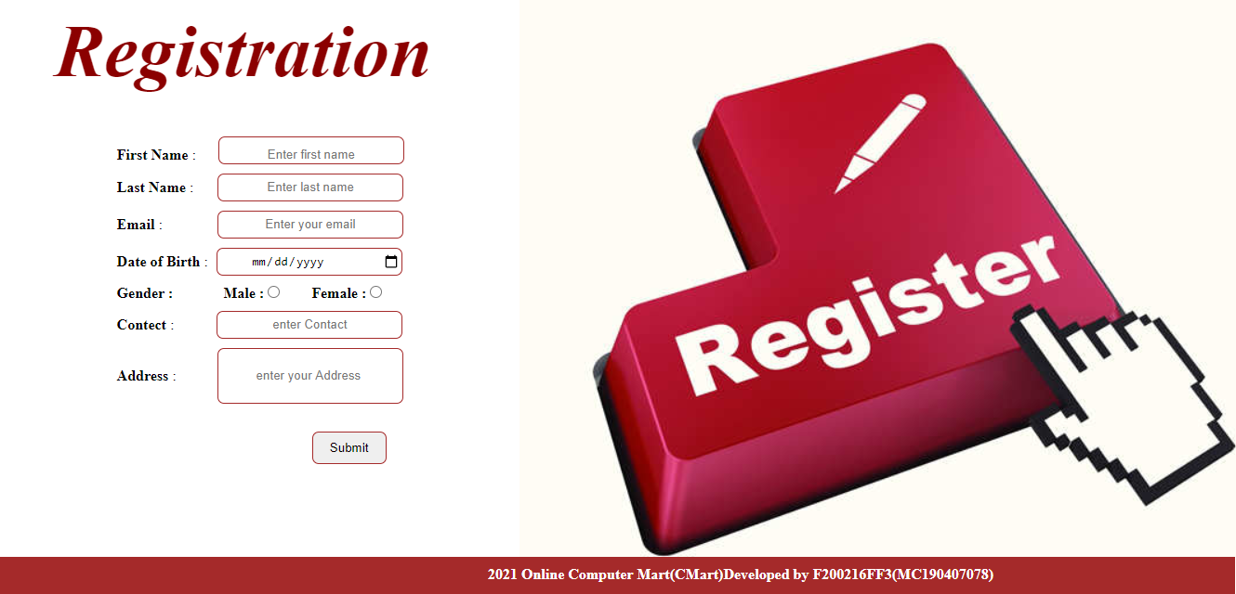

1. **Invoice Bill Page:**

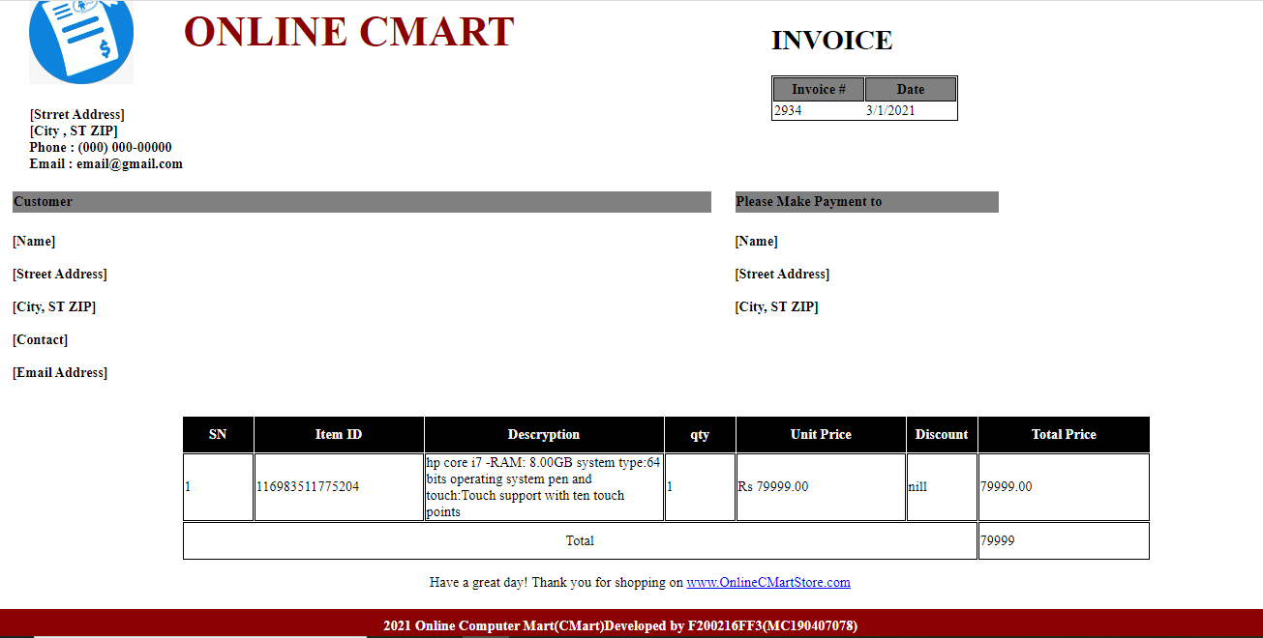

**Test Cases**

|  |  |
| --- | --- |
| **Test Case ID:** | **01** |
| **Test Case Title:** | **Login** |
| **Description:** | User wants to Login into the system. A username and password is required to login into the system. |
| **Actors:** | Admin and Customer |
| **Pre-Conditions:** | * User has a Valid Username. * User has a Valid Password. |
| **Test Steps:** | 1. User navigates to the Login Page. 2. User enters the valid Username. 3. User enters the valid Password. 4. User clicks on “Login” button. 5. System validates the entered Username and Password. 6. System navigates the user to the dashboard after successful Login. |
| **Expected Results:** | User should be able to login into the System. |
| **Actual Results:** | User is redirected to the dashboard with successful Login. |
| **Status (Pass/Fail):** | **Pass** |
| **Tested By:** | **F200216FF3 (MC190407078)** |

|  |  |
| --- | --- |
| **Test Case ID:** | **02** |
| **Test Case Title:** | **Register** |
| **Description:** | User wants to Register into the System. |
| **Actors:** | Guest |
| **Pre-Conditions:** | * User wants to register into the System. * System should be running properly. |
| **Test Steps:** | 1. User navigates to the Registration page. 2. User provides the required information for Registration. 3. User clicks on “Register” button. 4. System validates the entered user information. 5. System displays a message “Registration Successful” after successful registration. |
| **Expected Results:** | User should be able to Register into the system. |
| **Actual Results:** | User is Registered successfully. |
| **Status (Pass/Fail):** | **Pass** |
| **Tested By:** | **F200216FF3 (MC190407078)** |

|  |  |
| --- | --- |
| **Test Case ID:** | **03** |
| **Test Case Title:** | **Search for CMart Item** |
| **Description:** | User wants to search a product/item in the Design and Development of Online CMart Website. User will have to type the title or any keyword related to his search input to make a search. |
| **Actors:** | Admin and Customer |
| **Pre-Conditions:** | * System is running properly. * Application is connected to the database. * User is logged into the system. |
| **Test Steps:** | 1. User navigates to the “Products/Items” page. 2. User clicks on “Search” button. 3. System asks the user to enter the Product title or description words as an input to make the search happen. 4. User enters the input and clicks on “Search” button. 5. System displays the search results. |
| **Expected Results:** | User should be able to search a Product/Item in the CMart System. |
| **Actual Results:** | User has searched a product/item successfully. |
| **Status (Pass/Fail):** | **Pass** |
| **Tested By:** | **F200216FF3 (MC190407078)** |

|  |  |
| --- | --- |
| **Test Case ID:** | **04** |
| **Test Case Title:** | **Manage CMart Items** |
| **Description:** | User wants to manage the CMart Item product/items. User can add a new product/item in the CMart system. User can update the details of an existing product/item. Also user can delete an existing product/item. |
| **Actors:** | Admin |
| **Pre-Conditions:** | * System is running properly. * Application is connected to the database. * User is logged into the system. |
| **Test Steps:** | 1. User will click on “Manage Products/Items” button. 2. System will show all the products/items available in the Auction system. 3. User will search/select an item he/she wants to manage.   3.1 User will add a new product/item in the Auction system.  3.2 User will update and existing item.  3.3 User will delete and existing item.   1. User will click on “Save” button after he/she made any changes. 2. System will save the changes made by the user. |
| **Expected Results:** | User should be able to manage the products/items in the CMart system. |
| **Actual Results:** | User has managed the products/items in the CMart System successfully. |
| **Status (Pass/Fail):** | **Pass** |
| **Tested By:** | **F200216FF3 (MC190407078)** |

|  |  |
| --- | --- |
| **Test Case ID:** | **05** |
| **Test Case Title:** | **Manage Customers** |
| **Description:** | User wants to manage the Customers / users in CMart System. Only the Admin is allowed to manage users. Admin will look up the various fraud buyers and then block that customer account permanently. |
| **Actors:** | Admin |
| **Pre-Conditions:** | * System is running properly. * Application is connected to the database. * User is logged into the system. |
| **Test Steps:** | 1. User will click on “Manage Users” button. 2. System will display all the user’s information. 3. User will select a buyer and click on “Block/Active” button. 4. System will save the changes made by the user. |
| **Expected Results:** | User should be able to manage the users in Auction System. |
| **Actual Results:** | User has manage the Buyers successfully. |
| **Status (Pass/Fail):** | **Pass** |
| **Tested By:** | **F200216FF3 (MC190407078)** |

|  |  |
| --- | --- |
| **Test Case ID:** | **06** |
| **Test Case Title:** | **Allocate Unique Identifier number (Order_ID)** |
| **Description:** | User wants to allocate a Unique Identifier number. Admin must verify the request of a valid buyer for but code for CMart website users. |
| **Actors:** | Admin |
| **Pre-Conditions:** | * System is running properly. * Application is connected to the database. * User is logged into the system. |
| **Test Steps:** | 1. User will click on “Allocate a Verification Number” button. 2. System will display an input form to type a verification number or to generate a random Unique Identifier number. 3. User will enter the Unique Identifier number. 4. User will click on the “Allocate this Number” button. 5. System will save the allocated code. |
| **Expected Results:** | User should be able to allocate a Unique Identifier number. |
| **Actual Results:** | User has allocated a Unique Identifier number successfully. |
| **Status (Pass/Fail):** | **Pass** |
| **Tested By:** | **F200216FF3 (MC190407078)** |

|  |  |
| --- | --- |
| **Test Case ID:** | **07** |
| **Test Case Title:** | **Make Payment** |
| **Description:** | User wants to make Payment Online. Customer can pay via credit card. |
| **Actors:** | Customer |
| **Pre-Conditions:** | * System is running properly. * Application is connected to the database. * User is logged into the system. |
| **Test Steps:** | 1. User will click on “Pay Online” button. 2. System will display a Payment Form to fill. 3. User will fill the necessary fields of Form. 4. User will click on “Make Payment” button. 5. System will process user’s request. |
| **Expected Results:** | User should be able to make Payment online. |
| **Actual Results:** | User has made Payment Online. |
| **Status (Pass/Fail):** | Pass |
| **Tested By:** | **F200216FF3 (MC190407078)** |

|  |  |
| --- | --- |
| **Test Case ID:** | **08** |
| **Test Case Title:** | **Place Order** |
| **Description:** | **08** |
| **Actors:** | Customer |
| **Pre-Conditions:** | * System is running properly. * Application is connected to the database. * User is logged into the system. |
| **Test Steps:** | 1. User then click on “Products” button displaying on the page. 2. System then displays the Products list. 3. User then is choosing a Product which he/she wants. 4. User then click on “Place Order” button displaying on the page. 5. System then add that Product into his/her Cart. 6. User then click on “Proceed” button displaying on the page to confirm the Purchase. 7. Users then confirm his/her Placed Order. |
| **Expected Results:** | User should be able to Place an Order Online in. |
| **Actual Results:** | User has made Payment Online. |
| **Status (Pass/Fail):** | **Pass** |
| **Tested By:** | **F200216FF3 (MC190407078)** |

|  |  |
| --- | --- |
| **Test Case ID:** | **09** |
| **Test Case Title:** | **Track Orders** |
| **Description:** | **09** |
| **Actors:** | Admin and Customer |
| **Pre-Conditions:** | * System is running properly. * Application is connected to the database. * User is logged into the system. |
| **Test Steps:** | 1. User then click on “Track Order” button displaying on the page. 2. Systems then display the form and ask for the order no. to enter. 3. Users then provide the Order No. 4. System then looks for that Orders in the system. |
| **Expected Results:** | User should be able to track his / her orders. |
| **Actual Results:** | User has made seen her order status. |
| **Status (Pass/Fail):** | **Pass** |
| **Tested By:** | **F200216FF3 (MC190407078)** |

|  |  |
| --- | --- |
| **Test Case ID:** | **10** |
| **Test Case Title:** | **Generate Invoice Bill** |
| **Description:** | **10** |
| **Actors:** | Admin |
| **Pre-Conditions:** | * System is running properly. * Application is connected to the database. * User is logged into the system. |
| **Test Steps:** | 1. User then click on “Generate Invoice Bill” button displaying on the page. 2. System then displays the Search or Filters to choose and to choose the order. 3. Users then select an order and clicks on “Generate Invoice Bill” button displaying on the page.    1. System then calculates and display bill. 4. System then Generate Invoice Bill. |
| **Expected Results:** | Admin should be able to generate the invoice bill. |
| **Actual Results:** | Admin has generated invoice bill. |
| **Status (Pass/Fail):** | **Pass** |
| **Tested By:** | **F200216FF3 (MC190407078)** |

|  |  |
| --- | --- |
| **Test Case ID:** | **11** |
| **Test Case Title:** | **View Cart** |
| **Description:** | **12** |
| **Actors:** | Admin |
| **Pre-Conditions:** | * System is running properly. * Application is connected to the database. * User is logged into the system. |
| **Test Steps:** | 1. User then click on “View cart” button displaying on the page. 2. System then displays the cart and information in it. 3. User then manages the cart information. 4. System then saves the changes made by user. |
| **Expected Results:** | User should be able to manage his / her cart.. |
| **Actual Results:** | User has viewed or managed cart in. |
| **Status (Pass/Fail):** | **Pass** |
| **Tested By:** | **F200216FF3 (MC190407078)** |

|  |  |
| --- | --- |
| **Test Case ID:** | **12** |
| **Test Case Title:** | **Recover Password** |
| **Description:** | **13** |
| **Actors:** | Admin and Customer |
| **Pre-Conditions:** | * System is running properly. * Application is connected to the database. * User is logged into the system. |
| **Test Steps:** | 1. User then click on “Forgot Password” button displaying on the page. 2. System then displays the form to fill and ask for email. 3. User then enters his/her email.    1. System then sends password recovery email. 4. User recovers his/her password. |
| **Expected Results:** | User should be able to recovered his/her password in. |
| **Actual Results:** | User has recovered his/her password in. |
| **Status (Pass/Fail):** | **Pass** |
| **Tested By:** | **F200216FF3 (MC190407078)** |